MINUTES OF ESAPP COORDINATION MEETING HELD VIRTUALLY ON 30.4.2025

# Overview

The Eastern and Southern Africa Prolinnova Platform (ESAPP) meeting was a follow-up to one held in October last year as a part of inter-Country Platform (CP) networking and strengthening of the Prolinnova ESA Platform. In the previous meeting, the CPs had proposed membership in the membership of ESAPP as per the ESA Charter and CPs and agreed on having two representatives from each CP at the ESAPP. These included the CP Coordinator and one additional person. It also agreed that once the ESAPP membership is confirmed, the Platform members would embark on setting up coordination and governance structures: the Eastern and Southern Africa Subregion Support Team (ESAST) and the Eastern and Southern Africa Prolinnova Programme Oversight Group (EOG).

The main aim of this meeting therefore was to follow up on these agreements and confirm the names of members of the ESAPP, identify members of the ESAST and process of nominating for voting members of the EOG. The meeting also provided an opportunity platform for representatives of CPs from the Subregion who were present, Kenya, Uganda, Sudan, South Africa, and Mozambique, to deliberate on how to strengthen the governance structures at the subregional level and share their respective activities.

# Participants

1. Mawahib Mohamed – Country Platform Coordinator, Prolinnova Sudan
2. Mohamed Mabrouk – Chairperson Prolinnova Sudan
3. Domingos Tsucane –Member, Prolinnova Mozambique
4. Rumuald Rutazihana – Member, Prolinnova Mozambique
5. Jacinta Nekesa – Country Platform Coordinator, Prolinnova Uganda
6. Daudi Ssentongo – NSC Chairperson, Prolinnova Uganda
7. Martha Opondo – Member, Prolinnova Kenya
8. Vincent Mariadho – Country Platform Coordinator, Prolinnova Kenya
9. Refiloe Thabejane – Member, Prolinnova South Africa
10. Tema Mathebula – Member, Prolinnova South Africa
11. Koki Mphahlele –Member, Prolinnova South Africa
12. Richard Chuene – Country Coordinator, Prolinnova South Africa
13. Ernest Letsoalo – Prolinnova ESA Representative at POG
14. Brigid Letty – Prolinnova IST/POG
15. Jacob Wanyama – ESA Sub-regional Coordinator/Secretariat

# Absent

1. Elias Zerfu – Contact person, Prolinnova Ethiopia/ISNAR
2. Benza Kifle- Contact Person, Prolinnova Ethiopia
3. Gilda Fafitine – CP Coordinator, Prolinnova Mozambique
4. Righa Makonge – Member, Prolinnova Kenya/WN

# Proceedings

## ****Meeting Introduction and Participant Introductions****

* Jacob Wanyama, the ESA Subregional Coordinator facilitated the meeting. He welcomed participants to the first ESA platform meeting of the year and thanked them for finding time to attend especially that some of them are facing challenges related to ongoing conflicts in their countries.
* He then facilitated self-introduction’s introductions, and then then introduced the agenda as shown in Box 1 below
* Some participants noted challenges their CPs are facing. Mohammed Mabrouk, the Chairperson of Prolinnova Sudan explained that he had to leave Sudan due to civil war and Domingos Tsucane from Mozambique mentioned the impact of recent incidents in Mozambique that affect innovations in Chibutu, one of Prolinnova Mozambique learning site.

**Box 1: Meeting Agenda**

1. Self-Introduction
2. Review the minutes of the last Coordination Committee Meeting of October
3. Recap on the ESAPP Governance Structure
4. Confirming names of members of the ESAPP.
5. Identifying members of the ESAST – Two – CP Who are members of Platform
6. Nominating for voting EOG members – 3 CP + 2 Independent
7. Any communications on forthcoming Prolinnova subregional, regional and global events.
8. Identify and plan any cross-CP/subregional initiatives.
9. AoB

## ****Review of Previous Minutes****

* Jacob reviewed the minutes from the October 2024 meeting noting that the meeting discussed the need governance structure for the ESAPP and the importance of the ESA Platform charter as a guiding document for the platform.
* The previous meeting initiated the process of establishing the membership for the ESAPP and identified the next steps namely, each CP was to identify the two people who will represent the respective CPs on the ESAPP.
* The names of possible members which had been submitted in a previous meeting were confirmed except for a few CPs who had submitted more than two names or had requested more consultation. These included:
* Ethiopia – which was to clarify the status of the CP’s governance structure and representation. Elias was acting and Benza attended the last meeting and were proposed as representatives.
* Sudan- where the Coordinator Mawahib was asked to check with Mohamed Mabarouk, who was proposed as the second person on his willingness and availability.
* South Africa – Richard Chuene the CP Coordinator needed to identify an extra person to join with the CP.
* Uganda – where the CP Coordinator, Jacinta Nekesa was asked need to decide which two of the three names which had been included in the list should sit on the ESAPP.
* The meeting that had been agreed on for 15th November 2024, to deliberate on the next steps did not take place. Also, the CPs that had been asked to consult and send confirmed names were not able to.

## ****Governance Structure Explanation****

* Using the Diagram from the ESA Charter shown in Appendix 1, Jacob explained the three key structures that need to be formed: the ESA Prolinnova Platform (ESAPP), the ESA Support Team (ESAST, and the ESA Oversight Group (EOG)
* He explained that the ESAPP consists of two people from each active CP.
* The ESAST should have two members drawn from the platform representatives to work with the sub-regional coordinator.
* The oversight group should have five members (three from CPs and two independent)
* There was discussion about membership status and representation from countries like Sudan where conflict has affected activity.

## ****Confirmation of Representatives at the ESA Prolinnova Platform (ESAPP)****

* Each country’s two representatives were confirmed for the platform membership
* South Africa confirmed Tema as their second representative alongside Richard
* Uganda confirmed Jacinta Nekesa and Daudi Ssentong as their representatives
* Mozambique nominated Romuald Rutazihana to join Gilda Fafitine as their representatives
* Kenya confirmed Makonge Righa and Vincent Mariadho as their representatives
* Sudan confirmed Mawahib Ahamed and Mohamed Mabrouk as their representatives
* The confirmed full list is shown in Appendix 2.

## ****ESA Platform Support Team Selection****

* Jacob explained the structure of the Eastern and Southern Africa Platform Support Team.
* Vincent sought clarification on support team membership guidelines
* Jacob clarified that the support team will have just two people selected from among the platform members.
* Jacob asked members present to volunteer if they would like to join the ESAS Tapon which Mawahib from East Africa and Richard from South Africa volunteered.
* Martha explained that the two members come from the full ESA platform rather than two from each country.

## ****Oversight Group Formation Discussion****

* Jacob Wanyama reiterated that the Oversight group should have three members from CPs (who are not members of the ESAPP) plus two independent members making it five in total.
* He clarified that these members would come from countries but not necessarily from the platform membership list.
* He compared the structure to Prolinnova International’s POG structure with Ernest as a current member representing the ESA Subregion.
* Mawahib requested a clearer explanation of the governance structures while Mohammed sought clarification on how the regional structure relates to country-level structures.
* Jacob explained how the three groups relate to each other in the coordination and governing of the network with ESAST focusing on Coordination and Networking roles while EOG focusing on governance and policy issues.
* He explained these are new structures being decentralized from the global level.

## ****Nomination Process for Oversight Group****

* Jacob requested nominations for the oversight group members
* Daudi suggested giving participants time to reflect and consult within their CPs
* The emphasis that oversight group members should be at the policy level and have an influence
* A dateline of Wednesday 7th May 2025 was set for submission by the CPs of their nominations for the people who would be on the EOG.

## ****Member Profile Requirements and Next Steps****

* Martha suggested creating profiles for nominees to inform voting decisions
* Mohammed recommended oversight members should be from the key stakeholders: academia, research, Extension, NGO and Farmers.
* Discussion about ensuring balance across different sectors (NGOs, academia, research, extension)
* Agreement to follow up with guidance on qualities needed for oversight group nominees

# Action Items

**Wanyama**

* Send follow-up communication with guidance on qualities needed for oversight group nominees by Friday 2nd May 2025
* Receive nominations for the oversight group members from CPs on 7th May 2025
* Facilitate voting by the CPs for three CP representative seats. (Please note that the be two (2) independent members will be chosen by the International POG in this initial stage but subsequently by the EOG members once formed).
* Share the voted names with the Prolinnova IST then Publish the confirmed names of platform members on the PROLINNOVA website.

**Domingos**

* Ensure Gilda confirms Romuald as the second Mozambique representative

**Richard**

* Confirm Tema as the second representative for South Africa

**All Country Platforms**

* Conduct internal consultations to identify nominees for the oversight group.
* Submit nominations for the oversight group by the deadline to be communicated.

# Communications from CPS, ESA Secretariat and IST.

* Mozambique (Domingos) reported that the unfortunate events that happened in the country affected the CP learning site in Chibuto
* There is going to international partners workshop in Karera, South India this year in November 2025. Chesha of IST is in charge of organizing it together with a member of Prolinnova Asia. And has been in touch directly with CPs regarding the participation.
* Evaluation of ELI-FaNs Project will take place this year. Preparation for it is in top gear with sending out of call for technical and proposals. It will involve the CPs involved in the project and will look at previous projects as well
* PID training of trainers will take place in Senegal in July this year and some people from this platform will be attending
* The 11th Hour has funded a small study off local Innovation Support Funds/Facility. It will look at people involved in the LISF either in the current project previous initiatives like the fair project to document some lessons learnt. More information to come.
* The sub-region secretariat has been active in fundraising so far, we have attempted two. Previously with McKnight. Lately, we were invited to by Agroecology Fund to submit a proposal from the Eastern Africa. We submitted joint one that brings together Uganda and Kenya. In this subregion, the call focused on countries in the Eastern Africa and among the countries lists only four Kenya, Uganda, Ethiopia and Tanzania fall in membership of the ESA Platform. Out of these only Kenya and Uganda have active platform with strong governance structure.
* Mohamed Mobrouk reported that many of the members of the platform have been exiled due to the ongoing conflicts in Sudan. One of them, Mawhabi Ahamed, is the coordinator of the Prolinnova Sudan country platform. She has been trying to facilitate the establishment of Prolinnova Egypt. Mawahib confirmed this but said she has been facing challenges due to lack of resources.

# Appendices:

## Appendix 1: Prolinnova Coordination and Governance structure



## Appendix 2: Confirmed Members of the ESAPP and ESAST

| Country | Representatives | Gender | Roles/Affiliations | Status |
| --- | --- | --- | --- | --- |
| Ethiopia | Elias Zerfu | Male | Contact person (ISNAR) | Not Confirmed/Did not participate in this meeting |
| Benza Kifle | Female | Contact Person | Not Confirmed/Did not participate in this meeting |
| Sudan | Mawahib Ahmed | Female | CP Coordinator (NCR- IER & MT) | Confirmed and volunteered to be on ESAST |
| Mohamed Mabrouk | Male | NSC Chair (SECS) | Confirmed |
| Mozambique | Gilda Fafitine | Female | CP Coordinator | Confirmed |
| Romuald Rutazihana | Male | Independent CP Member | Confirmed/Volunteered for the ESAST to be on ESAST. |
| South Africa | Richard Chuene Sello | Male | CP Coordinator | Confirmed/Had volunteered for ESAST sit but later relinquished it for Romuald. |
|  | Tema Mathebula | Male | Member, Mahlathini | Confirmed |
| Uganda | Daudi Ssentongo | Male | CP NSC Chair (UNFFE) | Confirmed |
| Jacinta Nekesa | Female | Ag CP Coordinator (EA) | Confirmed |
| Kenya | Vincent Mariadho | Male | CP Coordinator (WN) | Confirmed |
| Righa Makonge | Male | Member, (WN) | Confirmed |
| Sub-regional Coordinator | Jacob Wanyama | Male | Secretary | Confirmed |
| IST member | Brigid Letty | Female | IST Rep | Confirmed |
| POG member | Ernest Letsoalo | Male | POG Rep | Confirmed |

## Appendix 3: TORs for Nominee for the EOG[1]

Just like the Prolinnova international network, the ESAPP will be governed by an ESA Oversight Group (EOG). EOG will therefore serve as a governance mechanism to ensure accountability of the ESAPP to the Country Platforms (CPs) within the Subregion, their constituencies, and donors. It will play a crucial role in maintaining transparency, effectiveness, and coordination within the Prolinnova network at the Subregional Level. The EOG shall have five members: three from the member CPs and two independent individuals from the subregion. The SRC will be the sixth member without voting rights (i.e. ex officio) and will assume the role of EOG Secretary. The EOG will hold regular virtual meetings (Ref: ESA Charter Page 6 para VIII).

The nominee for this position should therefore have qualities similar to those nominated to sit on the POG. These are:

1. Active involvement in the CPs
2. Significant experience working in agriculture and rural development sectors and programmes within the Eastern and Southern Africa
3. Ideally, experience in facilitating or actively participating in multi-stakeholder platforms or partnerships
4. Experience and passion for the application, promotion and institutionalization of participatory research and development (R&D), especially Participatory Innovation Development (PID) and promoting Local Innovation (LI) processes and approaches in agriculture and natural resource management (NRM).
5. Ideally, experience in mobilizing resources for R&D projects & programs
6. Have good networking skills, especially with strategic partners for resource mobilization and policy influencing/advocacy.
7. Demonstrated interest in working on agroecology issues
8. Have the capacity to bring strategic positions and ideas to the EOG
9. Willing and able to give time and thoughts to guiding Prolinnova at the Sub-region Level.
10. Willing and able to engage in virtual and face-to-face meetings as well as access to good electronic communication facilities (at least three times a year)
11. Good command of English language
12. Female candidates are encouraged

## Appendix 4: Steps to follow in nominating and electing members of EOG[2]

The CP representatives of the EOG will be elected democratically by the CP members of ESAPP. The two independent members will be chosen by the POG in the case of the initial EOG – and subsequently by the EOG members – from three nominated candidates (based on their interest, experience in promoting local innovation and PID in the subregion and the strategic position they hold to assist ESAPP in advocacy, fundraising and image building).

The Chairperson of the EOG will be elected by its members and he/she is expected to work very closely with the EOG Secretary (for the time being, the SRC) on subregional matters. Replacement of the EOG Chairperson will be facilitated by the POG if required.

* SRC ESA-SR to request CP coordinators to launch a call for nomination of not more than 2 persons per CP ensuring gender balance based on agreed criteria giving a closing date
* CP Coordinators launch a call for nomination and receive applications (résumé, bio, LoI) from potential candidates by the closing date.
* Once all the nominations have been received, CP Coordinators forward the nominations to the SRC who makes a long list and then a short list with the support from other ESAST and IST members.
* SRC holds an election by sending around the shortlist to all CPs for voting with a closing date. Each CP is allowed one vote.
* CP Coordinators discuss with their own CP members and agree on whom they as CP are voting for from the shortlist.
* Each CP submits the name of the person they have voted for from the shortlist to SRC.
* The votes from the different CPs are then aggregated by the SRC and the person who gathers the most CP votes gets the position.
* SRC contacts the EAST and IST with the name of the selected person for confirmation and informs all the CPs of the selection
* The SRC shared the vote aggregate results with the candidate and with all the CPCs (both those who participated and those who did not) for their information.
* The ESAST informs the IST of the candidate choice, who will be invited to the next ESAST meeting for orientation and elections of the Co-chair.
* ESAST announces the elected/selected candidate in the Prolinnova Google group and on the website.

***NB: All communications will be copied to all the CPs participating in the selection process***.

## Appendix 5: Roles of ESAST[3]

Box 2: Roles and responsibilities of the ESAST

* Technical advice to SRC
* Running secretariat
* Fundraising
* Linking with other platform – networking
* Managing guidelines – developing guidelines
* Networking and sharing such as ESA Subregion Partners Workshops (SR-PWs), Subregional Farmer Innovation Fai (SR-FIF) etc.
* Have one representative who is sitting in the POG
* Hold face-to-face meetings once a year if funds allow (Subregional Partners meeting)
* Organizing and chairing meetings and exchanges.
* Just like we have IPW we also need to hold subregional (bring all the CPs together and make decisions).
* Organizing and chairing meetings – workshop at SR – exchanges
* Prepare Annual Report – the Subregional Support team to make sure it happens. We normally have project reports and Subregional Reports. The SRC puts the reports on the web and produces a consolidated report – Annual Reports.

## Appendix 6: Screen Short of the Zoom Participants

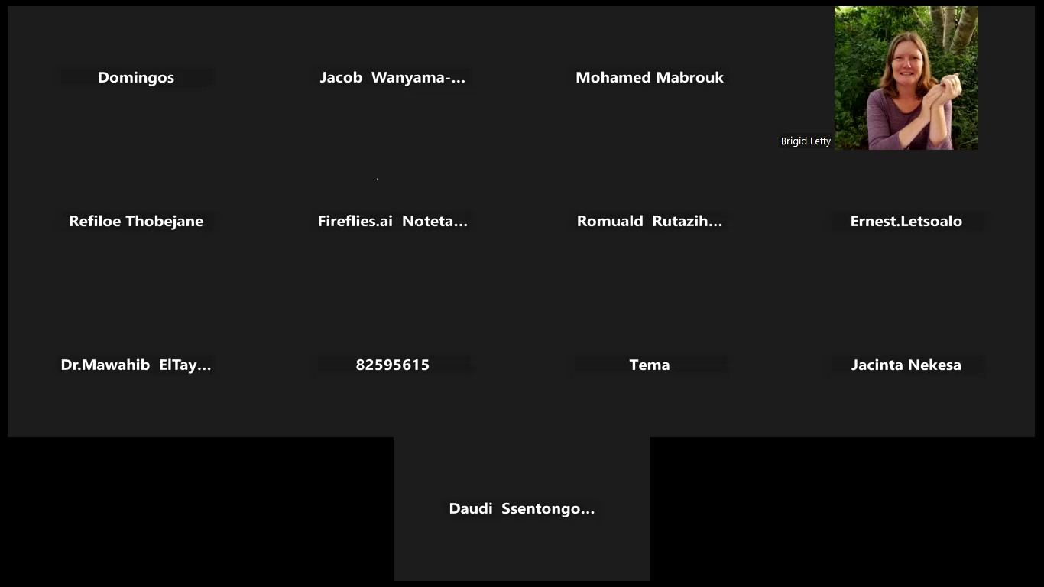

1. Source: ESA Charter
2. Source: ESA Charter
3. Adapted from the ESA Charter